1. 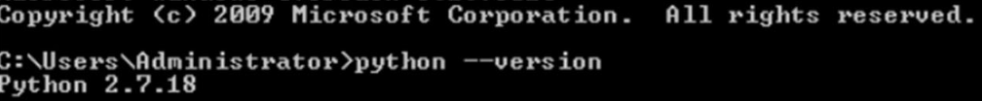
2. 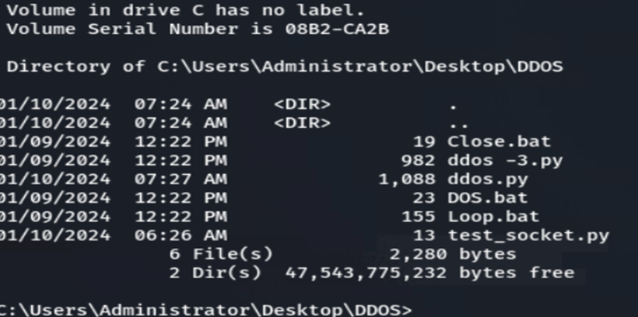
3. 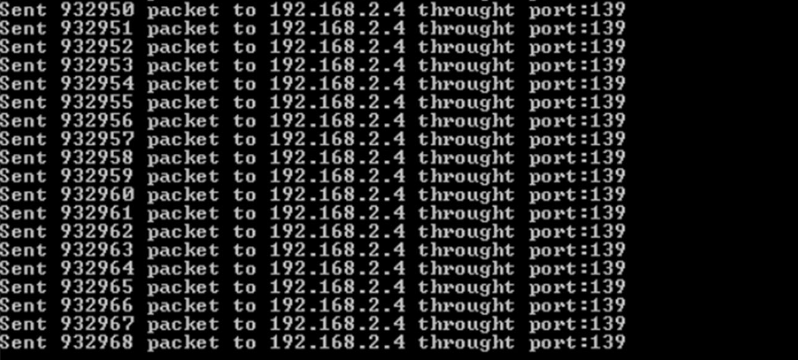
4. 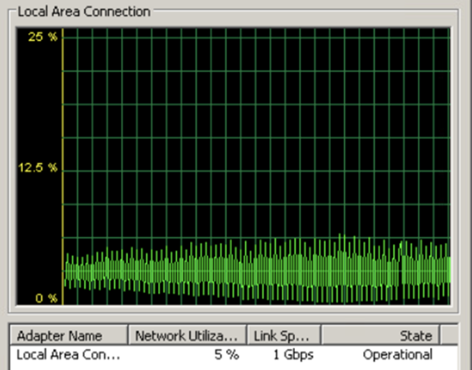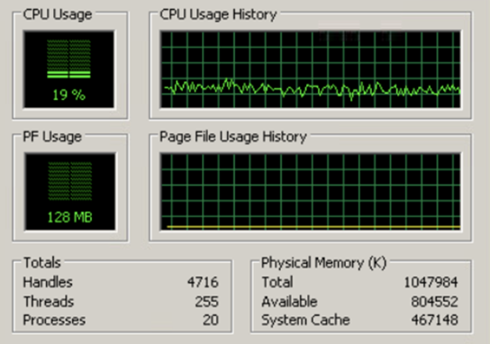
5. 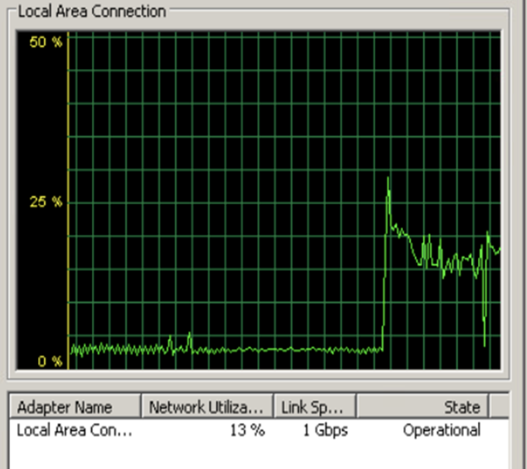
6. 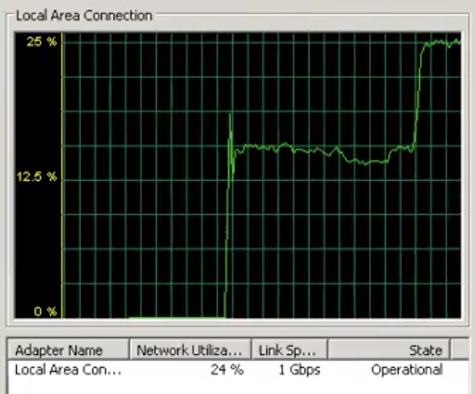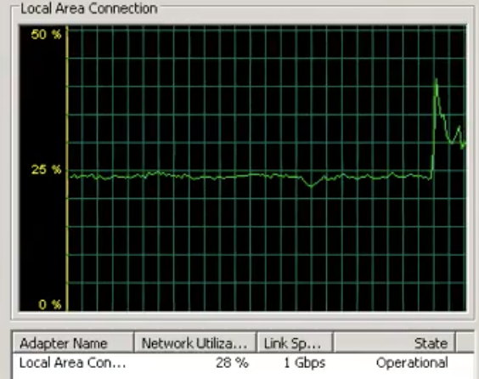

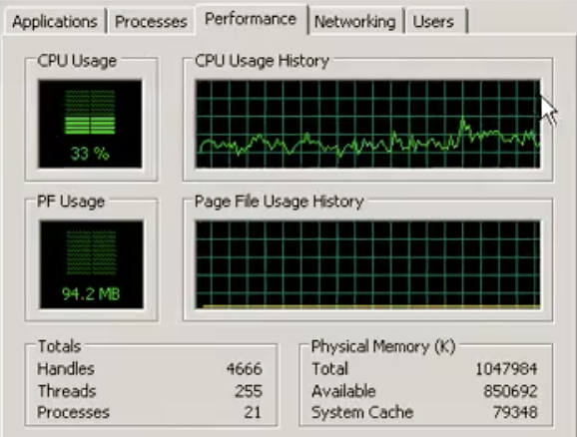

1. First of all, a DDos attack is a malicious attempt to disrupt the normal functioning of a targeted server, service, or network by overwhelming it with a flood of internet traffic. The goal of a DDos attack is to render the target inaccessible to legitimate users, causing downtime and potentially financial losses for the victim organization. There is a spike from windows 7 to kali linux to windows xp, but other than that it improved the performance chart by a little bit. Just noticed a spike and then a small improvement for all the different charts for each one.